SPS 2024: Rotary encoders for robotics and rotary encoders with extra functionality from the HEIDENHAIN GROUP

At SPS 2024 in Nuremberg, Germany, HEIDENHAIN and its brands AMO, RENCO and RSF will be showcasing encoders for the full spectrum of robotics and automation applications. Among the highlights are dual encoders and secondary encoders for advanced robotics, as well as inductive rotary encoders with added functionality, including the ECI 1323 Splus and EQI 1335 Splus with built-in vibration analysis. Using a cobot demo unit, HEIDENHAIN will be demonstrating how secondary encoders not only improve cobot accuracy but also enable collision monitoring without additional torque sensors.

Built-in vibration analysis:
The ECI 1323 Splus and EQI 1335 Splus inductive rotary encoders from HEIDENHAIN
Detecting machine vibration early on is vital for ensuring smooth processes, perfect results and machine longevity in high-performance production automation. The earlier vibrations are detected, the easier it is to prevent scrap, machine damage and system downtime. Featuring a built-in accelerometer, the HEIDENHAIN ECI 1323 Splus and EQI 1335 Splus inductive rotary encoders are new, convenient solutions for detecting and analyzing vibration in rotating machine components.

Thanks to their position feedback and vibration analysis, these encoders enable motion control and condition monitoring in a single device. Because these encoders link vibration to position, machine operators can more easily identify the type and location of the vibration’s source. An external temperature sensor can be connected as well. the ECI 1323 Splus and EQI 1335 Splus thus enable online condition monitoring, allowing machine faults to be detected and analyzed early on. Based on this condition monitoring data, machine operators can implement predictive maintenance to optimize their machine servicing intervals in accordance with wear levels and adapt their production schedules based on immanent breakdowns.

Collecting this machine data over extended periods also enables accurate forecasts regarding a machine’s remaining service life. Data from the ECI 1323 Splus and EQI 1335 Splus encoders is transmitted by the EnDat 3 interface, thereby eliminating the need for separate vibration sensors and significantly reducing the cabling and installation complexity.

Greater accuracy and safety for cobots:
Secondary encoders for collision monitoring
When robot joints are equipped both with an encoder for motor position feedback and a secondary encoder for position feedback downstream from the gearbox, robot designers can do more than merely improve the accuracy of their robots. They can also detect the effects of a robot’s exerted force and analyze the gearing forces in individual joints. Cobot manufacturers can leverage this data for collision monitoring without the need for additional torque sensors.

At SPS 2024, a cobot demo unit with secondary encoders from the HEIDENHAIN GROUP will be demonstrating this force measurement functionality. By watching a force gauge, observers can witness how the robot stays within defined force thresholds and how it switches off automatically when the exerted force exceeds 100 Nm, the critical limit for collisions between cobots and the human torso.

Modular angle encoders from AMO and RSF:
Secondary encoders for robot motors with wide shaft diameters
Robot manufacturers can significantly improve the absolute position accuracy of their robots by adding a high-accuracy angle encoder on each robot axis. Mounted downstream from the gear system, secondary encoders measure the actual position of each robot joint. Modular solutions, such as the WMRA angle encoder from AMO or the new MCR 16 angle encoder from RSF, are available for this type of application. Thanks to their modular design with a scale drum or measuring ring and a separate scanning unit, they are ideal for large shaft diameters and challenging installation constraints. The inductive secondary encoder solutions from AMO feature high robustness and a versatile mechanical design. The MCR 16 from RSF delivers optical scanning with improved signal quality for absolute position measurement on axes with large diameters.

EnDat 3 for the digital integration of encoders
The EnDat data interface from HEIDENHAIN is long-proven, continuously improving, and ready for the future of digitalization. EnDat ensures the easy and reliable integration of encoders into their larger systems. At SPS 2024, HEIDENHAIN will be demonstrating how three different encoders on a measuring arm can transmit their position, sensor and monitoring data over just four wires at a cycle time of 30 µs via EnDat 3 in bus operation. The benefits are reduced cabling, functional safety and extensive diagnostics. This makes EnDat 3 the ideal encoder interface for achieving high system integration, meeting the requirements of future digitalization, saving costs and realizing versatile machine architectures.

HEIDENHAIN at SPS, November 12 to 14, 2024
Hall 7, Booth 7-494

For more information, visit:  sps.heidenhain.com  www.heidenhain.com | Contact person for the trade press:  Ulrich Poestgens  DR. JOHANNES HEIDENHAIN GmbH  Dr.-Johannes-Heidenhain-Straße 5  83301 Traunreut, GERMANY  Tel.: +49 8669 31-4154  poestgens@heidenhain.de

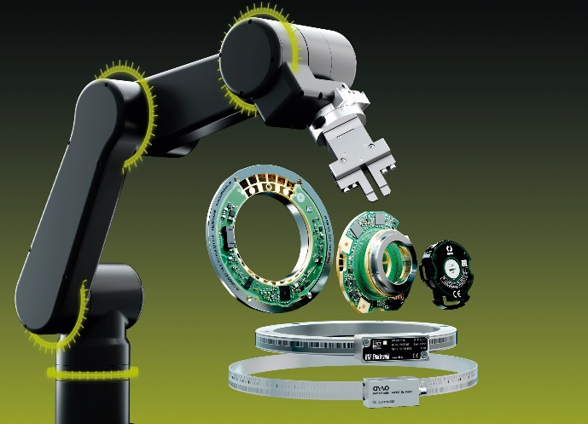 | Greater accuracy and functionality: the HEIDENHAIN GROUP offers smart solutions for the complete spectrum of robotics and automation applications.
 | High accuracy and collision monitoring without additional torque sensors: A demo unit at the HEIDENHAIN booth will be demonstrating the benefits of secondary encoders for cobots.

